Breakthrough Basketball Shot Chart
Date: _____________________ Opponent: ________________ Location: _______________

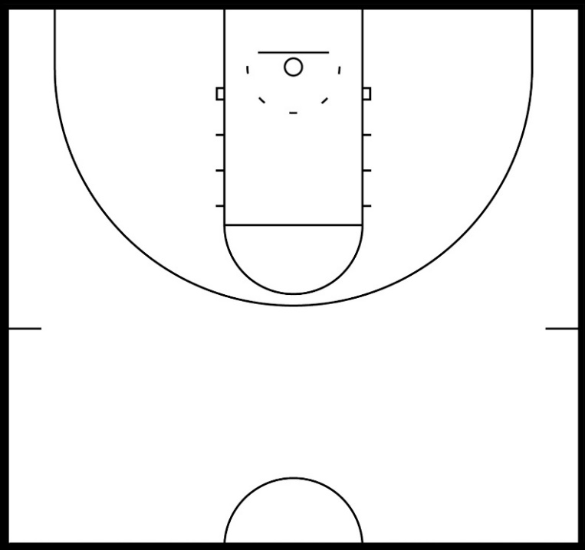
Quarter #1

Quarter #2

2PA: __________ 2PM: _________
3PA: __________ 3PM: _________
LA: __________ LM: ___________

2PA: __________ 2PM: _________
3PA: __________ 3PM: _________
LA: __________ LM: ___________

2PA: __________ 2PM: _________
3PA: __________ 3PM: _________
LA: __________ LM: ___________

Quarter #3

Quarter #4

2PA: __________ 2PM: _________
3PA: __________ 3PM: _________
LA: __________ LM: ___________

KEY – 2PA = 2-point attempts, 2PM = 2-pointers made, 3PA = 3-point attempts, 3PM = 3-pointers made
FGA = field goal attempts, FGM = field goals made, LA = lay-ups attempted, LM = lay-ups made
eFG = effective FG% (FG + 0.5*3PM)/FGA

1st Half: 1st Half Score:_______________
2PA: _______ 2PM: _______ %: _______ 3PA: _______ 3PM: _______ %: _______
FGA: _______ FGM: _______ %: _______ LA: _______ LM: _______ %: _______
eFG%_______

2nd Half:
2PA: _______ 2PM: _______ %: _______ 3PA: _______ 3PM: _______ %: _______
FGA: _______ FGM: _______ %: _______ LA: _______ LM: _______ %: _______
eFG%_______

Game Totals: Final Score:_______________
2PA: _______ 2PM: _______ %: _______ 3PA: _______ 3PM: _______ %: _______
FGA: _______ FGM: _______ %: _______ LA: _______ LM: _______ %: _______
eFG%_______

Individual Player Stats

# | 2PA | 2PM | 3PA | 3PM | LA | LM | FGA | FGM | FG% | eFG%

Visit www.BreakthroughBasketball.com for additional shooting guides as well as our Stats App with a built in shot chart.

